# Introduction to AI

**Module 1**

**Table of Contents**

Learning Objectives 4

Overview of AI 4

Artificial Intelligence (AI) 4

Need for AI 4

AI Fundamentals 5

Cloud Computing Services 5

Computer Vision 6

Natural Language Processing 9

Machine Learning 13

Areas of Application of AI in our Daily Life 16

Applications of AI in our Daily Life 16

Applications in AI 20

Personal vs. Digital Assistants 23

Chatbots 23

AI for Good 24

AI for Earth 24

AI for Cultural Heritage 27

AI for Accessibilty 29

AI for Humanitarian Action 30

AI for Health 32

Assessment 34

Practical Challenges/Further Learning on Microsoft Learn 35

Reference Links 37

Glossary……………………………………………………………………………...…………………………………39

**Disclaimer:**

The Imagine Cup Junior guides and lesson materials are created by Microsoft and our partners and intended to be for guidance only to support with the Imagine Cup Junior Challenge. For the latest on Microsoft AI please visit <https://www.microsoft.com/en-us/ai>

Learning Objectives

This module is designed to give students a basic understanding of Artificial Intelligence (AI) and its applications in everyday life. At the end of the module, students should be able to:

* Understand the basics of AI and other related concepts.
* Understand how AI can be used to solve problems in everyday life.
* Get started with their Imagine Cup Junior submission!

Overview of AI

# Artificial Intelligence (AI)

Artificial Intelligence (AI) is an integral part of our lives whether we realize it or not. When we book a ticket online, scroll through a newsfeed on social media, or go look at the recommendations from an ecommerce or video streaming site, we are dealing with an AI component in the background. Most chat assistants we encounter on websites or on our smartphones are driven by AI.

# Need for AI

Intelligence can be defined as the capability to obtain knowledge and skills and apply them to various situations without supervision to achieve a desired outcome. As is the case with children, intelligence is acquired through learning. As a child grows, they learn from their parents, siblings, teachers, friends and society in general. While some learning is taught, other concepts are learnt by observation of their environment and experiences.

The fundamental premise of AI is that we can create machines that can intelligently think in the same way humans think. It is designed to learn from the environment, the circumstances it is in and the things it interacts with (i.e. humans).

AI Fundamentals

# Cloud Computing Services

Cloud Computing is a system using a robust network of remote computers (called servers) hosted on the Internet that store, manage, and analyze data.

A cloud computing system keeps its data on Internet servers rather than on a local machine or personal computer.

Video and Music sharing cloud services stream data across the Internet to an app on the user's device rather than using a Digital Versatile Disc (DVD) or Compact Disc (CD).

Cloud computing is an integral part of advancing AI and other cognitive capabilities.

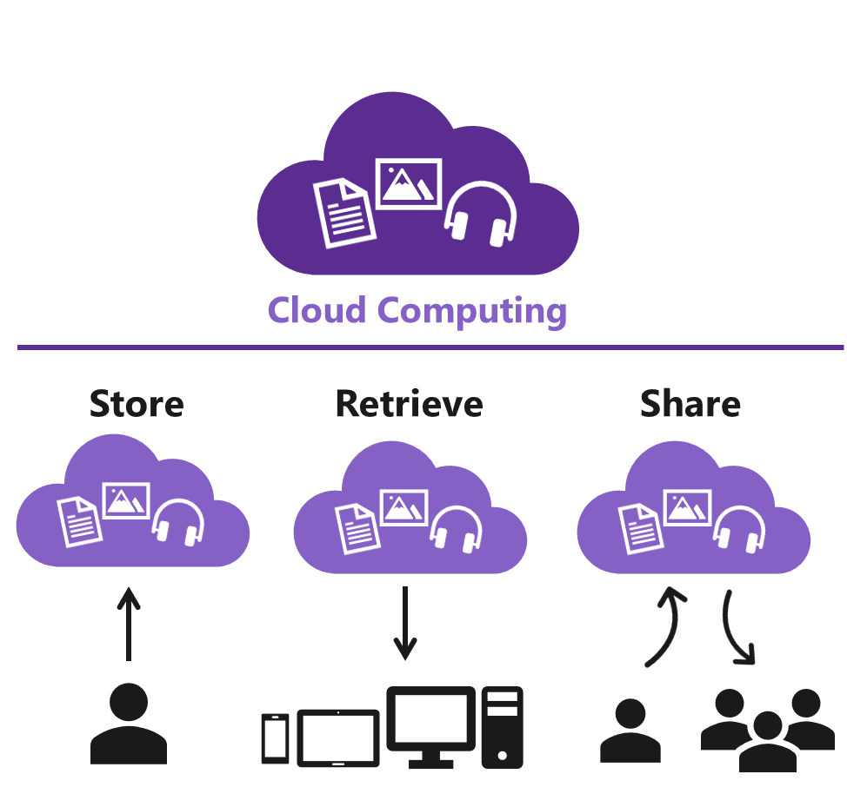

Fig 6.1: The working of cloud computing

**Computer Vision**

Computer vision is a field of artificial intelligence that trains computers to interpret and understand the visual world. Using still images and videos, machines can accurately identify and classify objects.

Below is a list of the main applications of Computer Vision.

## 

## Facial & Emotion Recognition

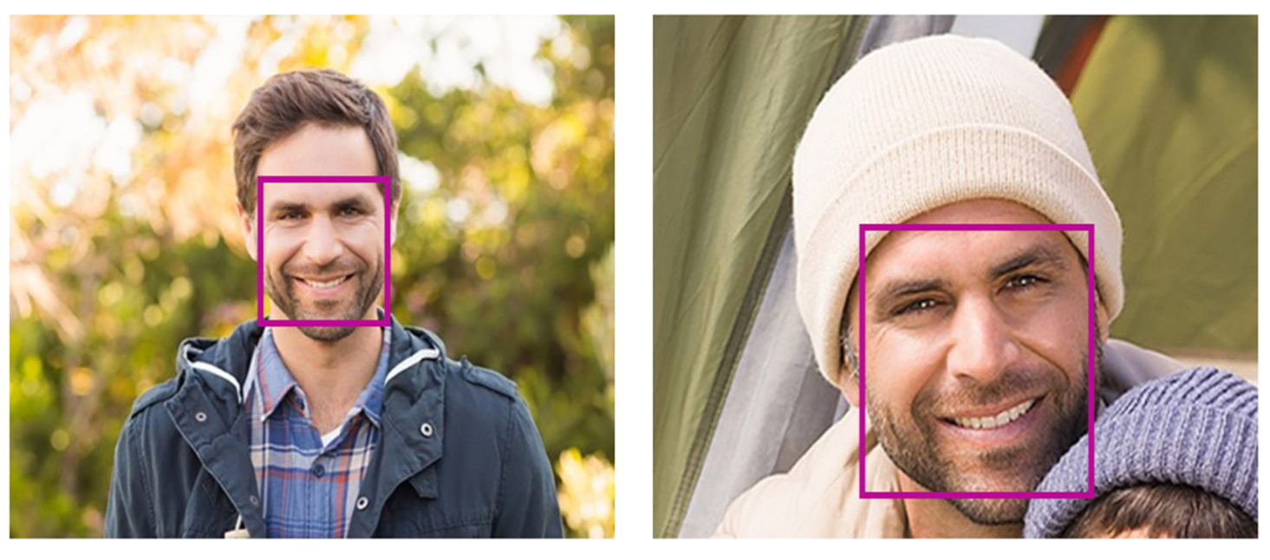

Fig 6.2: Face and emotion recognition

Face recognition applications are built to detect one or more human faces in a still image or video and, based on machine learning predictions of facial features, can also determine a person’s age, gender and even their emotions.

There are more than 27 landmarks for each face in the image, including:

* Age
* Emotion
* Gender
* Pose
* Smile
* Facial hair

Based on these ‘landmarks’, the application can do the following:

## Face identification

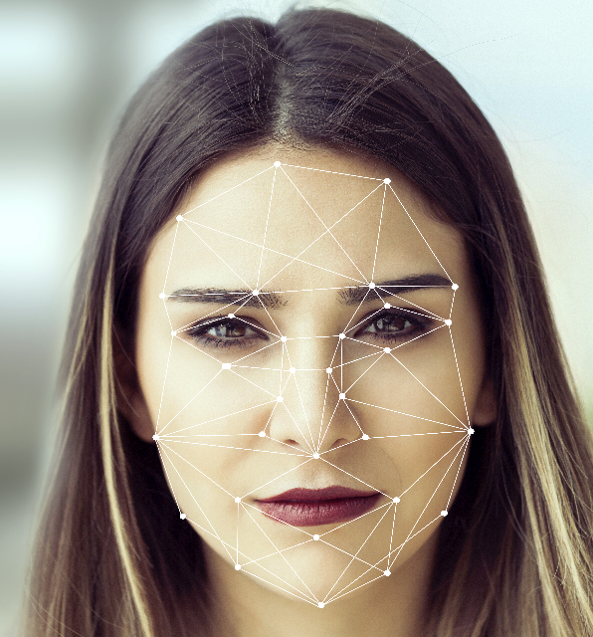

Fig 6.3: Face Identification

Face identification applications allow searching, identification and matching of faces based on training faces saved in a bank of up to 1 million people. The application searches the face of the human and matches certain points on the face marked as identifiers. It recognizes the face before giving the output.

## Similar face search

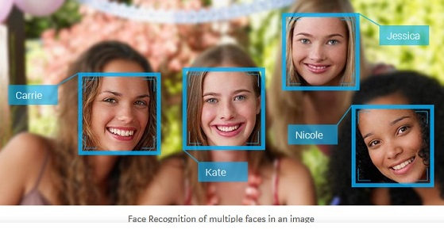

Fig 6.4: Searching for familiar faces and tagging them

A similar face search finds faces that look similar. A query to that effect returns a collection of similar faces as seen in the example mentioned above.

## Face grouping

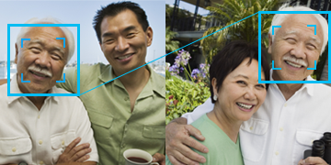

Fig 6.5: Grouping of similar looking faces in different images

In face grouping, images of unidentified people are organized based on the presence of a common face. You can observe a similar feature in some popular social media platforms which picks up random images and groups them based on the presence of the faces of people who are in your friends’ list. The application also automatically tags people to help the user.

## Emotion Recognition

Facial recognition software can also recognize the emotions displayed by the human face. The application distinguishes between emotions such as anger, happiness, contempt, fear, disgust, sadness, and even surprise. The application is smart enough to understand human emotions and expressions across cultures. It also understands the way people universally communicate using particular facial expressions.

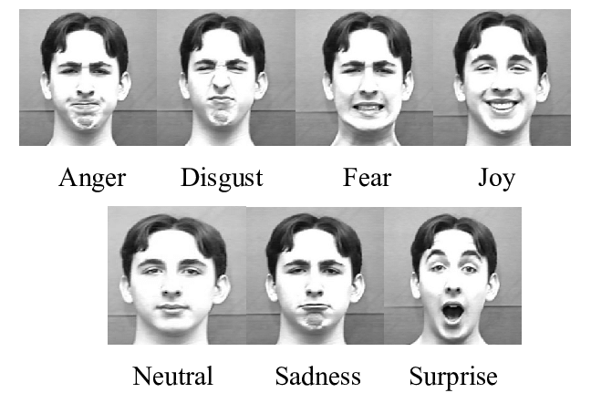

Fig 6.6: Basic six types of emotions

**Natural Language Processing**

One of the many challenges that are often faced in the realms of artificial intelligence is understanding human speech.

With the immense diversity of languages, accents and dialects, the process of deciphering human speech is quite difficult.

At times, the machine faces difficulties in learning constructs because there seem to be more exceptions to the rules of a language than rules themselves. Below is a list of the main applications of Natural Language Processing.

## Speech Authentication

The Speech Conversion AI is an enormously powerful tool capable of listening to a live voice or a recording and converting it into text. This can be an immensely powerful verification tool where the unique voice of a person can be used to validate the identity of the person. It is necessary to complete a process called ‘enrolment’ to train the application in the user’s voice.

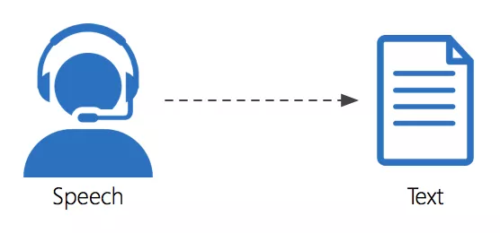

Fig 6.7: Process of Speech conversion into Text

This process is mandatory and requires the user to record three audio samples of his or her voice to register it with the software system.

## Conversation transcription

With the collaboration of different teams becoming a reality of modern work culture, conversation transcription can be very useful in meetings as it can create a transcript of the meeting, allowing participants to check their notes against the full transcript later on. Or using other software applications, translate this into another language for participants from another country. The application captures the speech of all participants in the real-time scenario and creates a transcript. This enables participants to engage in the meetings/discussions irrespective of the geographical locations. Here are a few more benefits:

* It captures the voices of multiple participants in a given room.
* It safeguards the data by following the mandatory security and compliance certifications as per the industry guidelines.
* It supports meetings and conferences wherein there is the use of microphones and video cameras pairing them with the speech devices.

## Speech transcription

## 

## Speech transcription converts spoken audio into text. It can recognize audio from a microphone or pre-recorded audio file.

## The audio is then sent to the server for speech recognition and conversion into text.

## The application can be used to build voice-triggered smart apps and dictation software.

## Text Analytics

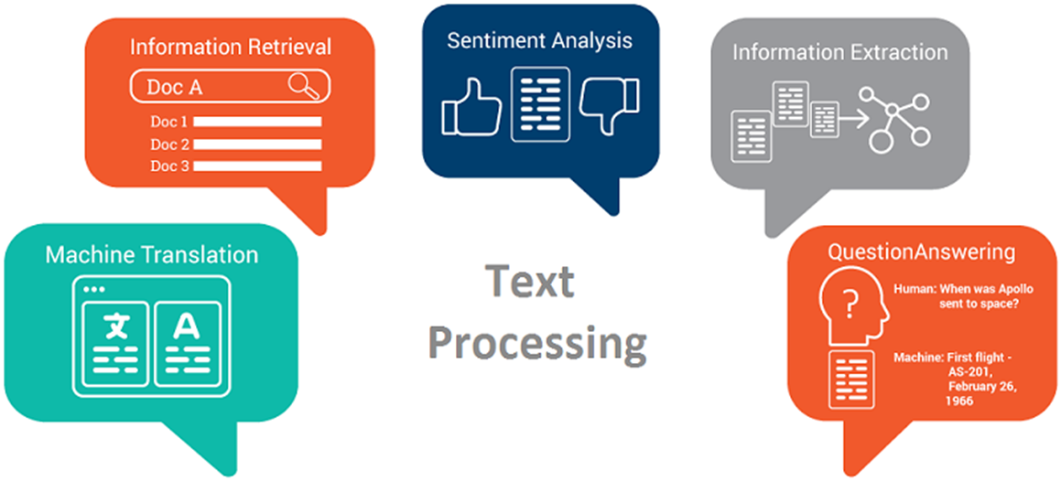

Fig 6.8: Process of Analysis of the Text

Text analytics is the process of converting unstructured text data into meaningful data for analysis, measurement of feedback, sentimental analysis, and other uses.

Text analytics applications can use sentiment analysis to understand the mood of the user and, in the case of Chatbots or other software, react accordingly.

For example, it may recognize that someone with mild Autism is feeling anxious and change the environment such as lighting or music accordingly. Another application would be to warn a young user in a Chatroom of possible danger based on the tone of the conversation.

## Sentiment analysis

Sentiment analysis returns a numeric score between zero (0) and one (1). Zero indicating 100% negative sentiment and one indicating 100% positive sentiment. It is generated using classification techniques and supports many languages.

**Example –**

Positive sentiment – I am feeling **happy** after getting my new T-shirt.

Negative Sentiment – I am **sad** because I missed the movie.

## Language detection

The API reads the detected language and a numeric score between 0 and 1 is then assigned to it. A score close to 1, is an indicator that the language identified is correct. A score farther from 1 and closer to 0 means an incorrect identification of the language. The API supports a total of 120 languages.

Example – “Find a Casa Colorida in your preferred location”.

English language – Find/ a/ in/ your/ preferred/ location/

Spanish Language – casa/ colorida

Since most of the words detected are in English, the language detected is English.

**Machine Learning – The foundation of Artificial Intelligence**

Machine learning is an application of artificial intelligence (AI) that gives machines the ability to automatically learn and improve from experience without being explicitly programmed. Machine learning focuses on the development of computer programs that can access data and use it learn for themselves.

## Machine Learning Methods

Machine learning algorithms are often categorized as supervised, unsupervised or reinforced. Let’s look at the three different methods.

## Supervised learning

Supervised Learning is the training of an artificial intelligence (AI) algorithm using information that has been labelled.

This can be thought of as a teacher providing students with the correct answers to a set of known questions upon which they can develop a strategy / learn how to answer similar questions.

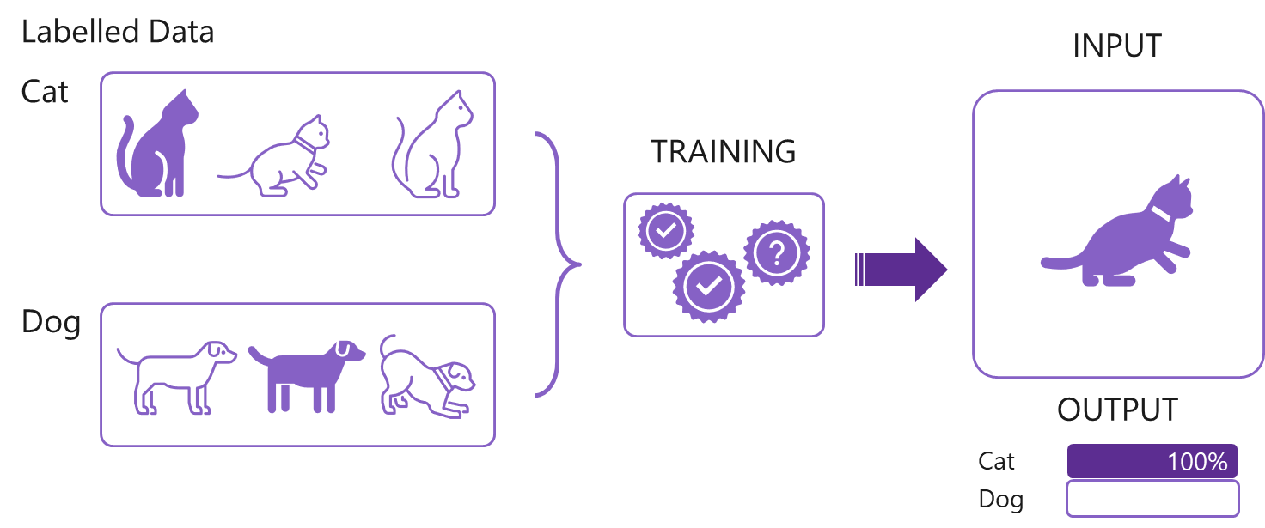

Fig 6.9: Pictorial example of Supervised learning

## Unsupervised learning

Unsupervised Learning is the training of an artificial intelligence (AI) algorithm using information that is neither classified nor labelled (known) and allowing the algorithm to act on that information without guidance.

Pictorial example of Unsupervised Learning


Fig 6.10: Pictorial example of Unsupervised learning

# Reinforcement learning

This form of learning is used in robotics, gaming and navigation applications. In reinforcement learning the algorithm discovers through trial and error which actions yield the greatest rewards. This type of learning has three primary components: the agent (the learner or decision-maker), the environment (everything the agent interacts with) and actions (what the agent can do).

The objective is for the agent to choose actions that maximize the expected reward over a given amount of time. The agent will reach the goal much faster by following a good strategy.

The goal in reinforcement learning is to learn the best strategy.

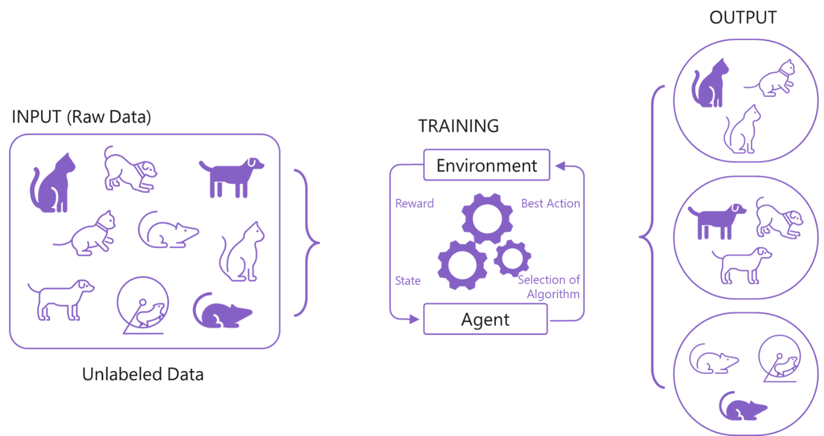

Fig 6.11: Pictorial example of Reinforcement Learning

Areas of Application of AI in our Daily Life

# AI Applications

## Healthcare

One primary aim of health-related AI applications is to analyze the relationships between prevention/treatment techniques and patient outcomes. AI programs have been developed and applied amongst others to practices such as the entire diagnosis processes, treatment development, drug development, customized medication, and patient monitoring and care (PwC, 2019).

The medical world is increasingly using AI and the Internet of Medical Things (IoMT) for helping citizens via the range of consumer health applications available today (PwC, 2019). Such medical applications are a great source of encouragement and support for people to develop and follow a healthy lifestyle. With proactive health management, technology has put the person in control of their own health and holistic well-being.

Additionally, advancements in AI have increased the rate of correct diagnosis and error-free application of treatment options. This has led to a better understanding of patients’ problems by doctors, and increased the rate of quality feedback, guidance and counselling, and the identification of other potentially related medical problems.

The inclusion of AI-based technologies in the medical world has improved services given the fact that the health sector generates large amounts of data which when processed leads to timely and appropriate decisions which can be taken by the doctors. This technology is known as predictive analytics and is often used to support data-based clinical decision making. AI uses pattern recognition to identify risk patterns in the patients or those who have a predisposition to certain diseases.

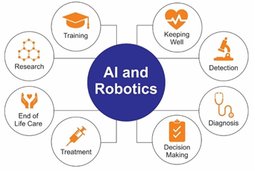

Fig 6.12 Areas of Use of AI and Robotics in Healthcare. Image Courtesy - (PWC, 2019)

In the past, robot arms were used in medical labs, however, with current developments in technology, AI-supported robots assist the doctors even during complex surgeries performing repetitive tasks and, in some cases, under control of the surgeon, take over elements of complex and delicate surgery.

Intelligent robots in the future will likely completely transform the way the elderly are cared for, giving them more independence and thus reducing the need of care homes and hospitalization. AI-based systems are being engaged to have human-like conversations with elderly people to keep their minds sharp as well as paying a variety of games to assist in warding off dementia.

## Agriculture

AI is being used extensively in agriculture (Intel, 2019). From counting the number of blooms to predict the yield in the fields, to the detection of pests and predicting which of the sown crops will yield the best possible returns, technology is being readied to meet a future global challenge. According to United Nations’ population division, the entire world population is estimated to touch 9.7 billion by the year 2050 (UN DESA, 2015) and the challenge we will face will be to feed such a growing population.

Microsoft in collaboration with ICRISAT, has developed an AI Sowing App powered by Microsoft Cortana Intelligence Suite including Machine Learning and Power BI. The app sends sowing advisories to participating farmers on the optimal date to sow. The best part – the farmers don’t need to install any sensors in their fields or incur any capital expenditure. All they need is a feature phone capable of receiving text messages (Microsoft 2017).

Artificial Intelligence can be used in agriculture to assist in weather prediction and simulate the impact of current and emerging trends on yield, and therefore global produce. Here are three major categories of applications of AI in agriculture:

* **Agricultural Robots** – Development and programming of autonomous machinery to manage essential tasks in agriculture such as harvesting of the crops at a higher volume and faster pace than human laborers. This will save both cost and time.
* **Crop and Soil Monitoring** – Advanced computer vision together with deep-learning algorithms are being developed to process data captured by drones and other technologies to monitor crops and soil health of vast geographical areas that are difficult, by their size, to manage by people.
* **Predictive Analytics** – Models are being developed with machine learning technology to track and predict various environmental impacts on crop yield such as weather changes, spread of pest and agricultural diseases etc.

## Retail

The future of retailing is in the partnership of employees with AI technology to introduce ways of optimizing the performance of the business. (Bayern, 2019).

AI in retail can be used in specific areas such as supply chain planning, demand forecasting, customer intelligence, marketing, advertising and campaign management, and pricing and promotion of products or services. AI can enable more efficient processing of supply chains and returns in the retail industry. It is also being used to develop chatbots which interact with customers to understand their enquiries or purchase and react accordingly. Development of customer-facing AI functionality such as self-service checkouts are designed to benefit retailers by reducing costs and increasing sales throughput, and assist customers in a trouble-free shopping experience, thereby increasing customer satisfaction.

How can AI help retailers in their business? As we all know AI is powered by data, the system needs to collect the right kind of data in order to recognize a pattern act on that pattern, learning as it goes, analyzing trends and commonalities in the data. Customer data is used to produce an appropriate model to solve specific problems such as customer satisfaction, purchasing trends, routes taken by customers through the store, maintain the correct stock level etc. (Hudson, 2019).

One of the many benefits of using AI-driven machines is that it can predict activities that increase sales (Trivedi, 2019). For example, if the customer is issued a cashback for a purchase, this may prompt them to buy more, therefore generating more sales. Another benefit of AI in retail is to improve the customer experience by strengthening engagement with the customer, with the aim of building a long-term loyal relationship.

The data set required in this example would be sales data correlated against customer information. This data set is run through the appropriate machine learning algorithm to produce an AI model. This model is translated into ways in which the retailer can increase turnover by providing the customer what they want and when they want it.

## Productivity at work

AI-powered applications and apps are prevalent at work too, assisting the human resources department in workforce recruitment. The technology helps managers come up with convincing job requirements using data from similar job postings which have borne fruit (Greene, 2019). AI is also supporting scheduling meetings, writing emails, making appointments and reminding people of various important business and personal tasks that one might miss out, thus helping users to manage their time well. This document itself was created using AI techniques in language definition by checking for correct spelling and grammar and suggesting possible changes to the wording.

Artificial Intelligence works independently of following instructions to fulfil repetitive tasks. The program is built to understand patterns and draw intelligent connections, thus enabling it to predict and fulfil the next set of instructions and tasks. Considering all the important factors this helps it to suggest potentially smarter business decisions to managers. Over a period of

time and upon handling multiple cases, the learning element of AI becomes more intuitive in processing the information. For example, it can propose new operations based on past budgetary results, talent cost, employment plans, etc.

Organizations can use AI-based applications to allow job candidates to schedule their interview with the interview panel at a time suitable for all parties. Some applications such as those used by Stella and Koru (Greene, 2019) make use of AI technology components to match the requirement of the employers to that of the candidates based on the candidates’ credentials, skills and the experiences. Another AI-based application known as the Palatine Analytics offers various tools to managers that help measure the performance of employees, and even select the right employee for promotion without the element of human bias.

## Personal Life

Our personal life is full of examples of AI being used daily. Our engagement is seamless and therefore goes almost unnoticed. However, many of the apps we run on our smartphones are all AI-powered. When we want to listen to music, we speak a command, our phone analyses our speech, understands the task, and runs a search to find the song before playing it.

Reminders for a meeting, or to buy groceries on a particular day for your parents or reminding you to study a particular subject for an upcoming test are all AI interventions in our daily life. The email spam filters that keep unwanted emails away from your inbox, or the social networking site which uses AI to personalize your newsfeed and ensures that you are seeing posts that interest you, are all examples of how AI has become an integral part of our day-to-day life.

**AI and Its Applications**

AI is growing in its applications, some even with impressive capabilities such as self-driving vehicles or social humanoids. Though currently, we do not have a fully functional AI based robot, it seems just a matter of time before we will have a fully functional humanoid capable of working with us or even supporting us in our homes. Here are a few applications which we regularly use which are extremely important in developing any technology that can engage in the same way humans can be in real life.

## Machine Translation

Thanks to AI, we have access to several different translation services. One of the most popular, Microsoft Translator, helps its user to easily translate a language. There is no need for complicated steps, AI has helped this application improve tremendously. From just typing a word, to pronouncing it and from single words to complete documents, Machine Translation has a lot to offer citizens of all nationalities.

## Customer Services

Chatbots are everywhere and you have surely encountered one. AI has played a major role in helping businesses by improving customer service and making it more accessible to its customers. Trained with large amount of data, chatbots can understand customer requests and also guide the customer and help them resolve their problem in a human-like manner. Plus, it saves up customer’s time and brings down the costs of business.

## Virtual Assistants

One of the most popular applications of AI is virtual assistants. Cortana is an example of one. These digital assistants are heavily reliant on AI to understand its user whilst at the same time give the appropriate response in a natural manner. Virtual assistants use AI to understand more about subjects they are asked about ranging from your favorite places to your favorite songs. Furthermore, virtual assistants are being incorporated to other devices from cars to microwaves, and thanks to smart devices and the internet, these assistants will continue to get smarter.

## Self-driving Cars

Due to AI, self-driving cars are able to become reality. Huge amounts of data is fed into the system to build a model, train the machine to learn, and then test the result in a safe environment. Data comes from cameras and sensors, whilst geo-mapping creates sophisticated models that can navigate the car through traffic and identify paths and signs. They could even find a parking space and park or drop you off and continue their journey.

## Colorizing Photos and Videos

Thanks to AI, machines can flaunt their creativity by adding color to old black and white photos and videos. This application has captured the hearts of the older generation by giving more life to a memory they never thought to see in colour again. Try it yourself with an old Black and White Photo from your grandparents.

## Fraud Detection

The banking and financial sector also benefit from AI, especially as money transaction are going digital. Furthermore, there are applications under development that will help detect fraudulent credit card transactions saving billions of dollars of in recovery and insurance of financial institutions.

## Healthcare

AI has been playing an important role in medical diagnosis and research. It helps with the diagnosis of life-threatening diseases, analyzing pathology results, and helps in understanding genetics to predict future risks of diseases. Robots driven by AI now support surgeons performing delicate surgery, although some medical practitioners are still skeptical about the use of AI in the field of medicine.

## Predicting Natural Disasters

In the long list of applications of AI, one of its most useful is in predicting earthquakes. The computation is very intensive but using AI can improve the calculation time by a huge amount. Also, when it comes to earthquake calculations, timing is always important and plays a vital role in saving people’s lives. Once perfected this type of Machine Learning, will save millions of people and is a great model to use on other natural disasters.

# Personal vs. Digital Assistant



A personal assistant is a person working exclusively for one particular person.

E.g., Peon, Secretary, Assistant

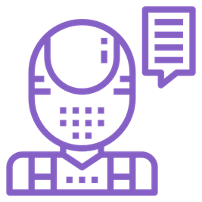

A digital assistant is a computer program designed to assist people.

E.g., Cortana, Alexa, Siri

Fig 6.13: Personal vs. Digital Assistant

# Chatbots

A chatbot is a computer program that simulates and processes human conversation (either written or spoken), allowing humans to interact with digital devices as if they were communicating with a real person.

Have you ever wondered why chatbots are created? They are meant to make it feel as if we are talking to a real human because this is what we are comfortable with.

AI for Good

# AI for Earth

How often have you heard that species of flora and fauna are facing extinction? Or forests are being cut down to create dwellings or factories? In these examples we find that due to gross exploitation of the natural resources of Earth, biodiversity is greatly affected. Animals, birds, and insects are losing their habitats, as we move in and decimate them for our own purpose. There are many areas on the Earth which are inhospitable for humans to live comfortably due to their hostile climatic conditions. However, this must not prevent us from conserving the flora and fauna at these places.

It is important for us to help preserve their habitats to conserve them. Together they maintain the balance of natural resources and the food cycle on Earth. The aim of using AI algorithms for the Earth is to create sustainable solutions across four areas, namely – water, biodiversity, agriculture, and climate change. These areas hold the key to the health of our planet and subsequently, the future of mankind.

In this sub module, we will explore the various partnerships that organizations have made with Microsoft to use their Azure cloud suite of services to help people save the planet.

# Sustainability for global fishing

According to the University of British Columbia, “countries drastically under report the number of fish caught worldwide. The new estimate released puts the annual global catch at roughly 109 million metric tons, about 30% higher than the 77 million officially reported in 2010 by more than 200 countries and territories. This means that 32 million metric tons of fish goes unreported every year, more than the weight of the entire population of the United States”.

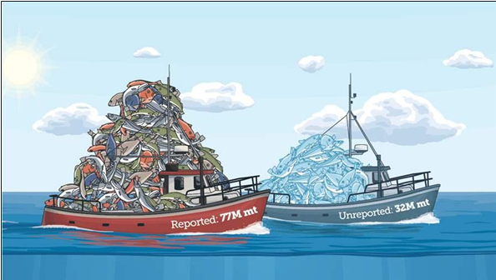

Fig 6.14: Reported and Unreported Fishing Data

Image source :(<https://www.pewtrusts.org/en/research-and-analysis/articles/2016/01/19/scientists-find-that-30-percent-of-global-fish-catch-is-unreported>, 2019)

The current challenge that the fishing industry is facing is the exploitation of our marine ecosystems, thus pushing many aquatic species towards extinction. Our oceans, seas and other water bodies are sources of food and livelihood to many people. The contamination of these water bodies through pollutants and plastic waste is detrimental not only to humans but also to the marine ecology.

OceanMind is one of many partners who, along with Microsoft, works with government agencies to protect fishing stock, store data on fishing vessel’s positions in the cloud and track each one in real-time. It uses sophisticated AI algorithms and Microsoft Azure suite of services to analyze the movements of the ship and identify any demonstrating suspicious behavior. This could include staying still in one place for too long, venturing into an area of water where they are not permitted, or going off an established route. OceanMind as a partner is committed to preserving the marine biodiversity of our oceans. The partnership uses satellites and AI to help preserve biodiversity, protect livelihoods, and prevent slavery in the seafood industry.

**Satellite imagery for forest management**

Conserving our forests and what is they contain (plants, animals, birds, insects etc.) will help us not only preserve its biodiversity but also help in tackling the challenges of global warming. It is essential to monitor our forests and the land they take up. Artificial Intelligence plays a particularly important role in such a scenario. SilviaTerra, an organization involved in forest management, together with Microsoft uses the Microsoft Azure suite of services to analyze high-resolution satellite imagery, the US Forest Service inventory, and field data in order to train machine-learning models to record relevant data of the forests and predict future scenarios.

# Enabling precision conservation and sustainable agriculture practices

In today’s age, as resources become scarce, it is imperative to ensure that we use the available resources in the best and most efficient way possible. In order to achieve this goal we should adopt sustainable agricultural practices such as precision farming or precision agriculture.

Precision farming can be understood as “the practice of farming by the more accurate and controlled growing of crops and raising livestock. A key component of this farm management approach is the use of information technology and a wide array of other technologies such as Global Positioning System (GPS) guidance, control systems, sensors, robotics, drones, autonomous vehicles, and GPS-based soil sampling,”.

[Video: Drones, scanners and GPS all part of 'precision farming' arsenal](https://youtu.be/tEj__Vo1WxQ)

Ag-Analytics partners with Microsoft in using sensors to collect soil, tillage, and yield data from specific plots of farmland. The data is stored in the Microsoft Azure cloud and is made available to farmers via user-friendly APIs to help them lower costs, improve farm yields, and minimize the ‘environmental cost’ of agriculture.

**Climate related risk**

One of the many changes that we see happening is global warming and its impact on climate change. Climate change is one of the biggest challenges that the world has ever faced. The consequences are enormous and are affecting not only we humans but also flora and fauna globally.

Subject experts passionately believe that AI can help us in this situation. Machine learning can be deployed to help tackle various challenges in the field of lessening carbon footprint, solar geo-engineering, educating the global population etc., which in turn can help in the cause of deforestation and creating energy efficient materials, thus a greener Earth. Though AI is not be a ‘solution’ to the problem, it can surely contribute to making the situation better in many ways. AI can help provide us with climate informatics, which is an amalgamation of aspects such as the prediction of extreme events, paleoclimatology, climate downscaling, and even large-scale models to predict weather.

**AI For Cultural Heritage**

Thinking of AI as a medium which changes our lives, what examples can you think of? Often the examples are chatbots, AI-powered personal digital assistants, apps working on sophisticated behavioral algorithms, AI-powered drones, self-driving cars, shopping bots, etc.

Recently, Microsoft has decided to explore and invest in the use AI to benefit mankind from an art and cultural perspective. This could change the way in which future generations view cultural icons and engage with their heritage. It is aimed at both the preservation of culture and making it more accessible to people.

In this endeavor, specific interest groups with domain expertise, work together to help preserve our cultural heritage in collaboration with local governments. A few notable examples include recreating an experience of the lifestyle, spoken languages and culture heritage of the past. The preservation of near-extinct languages, places, lifestyle and artifacts that we treasure as pieces of art, and the celebration of people who have made a lasting impact on the history of mankind and scientific evolution.

# Preservation and enrichment of cultural heritage around the world

The Musée des Plans-Reliefs in Paris has partnered with Microsoft, HoloForge, and Iconem to create “The Mont Saint-Michel: Digital perspectives on the model,” a HoloLens experience to celebrate French culture and innovation. The goal of this exhibit is to use augmented (mixed) reality technology in a way that empowers the Musée des Plans-Reliefs to unlock a more vivid kind of storytelling. The model of Mont-Saint-Michel is a rocky headland just off the Normandy coast that is home to a Benedictine abbey of architectural beauty in its own right and was presented by a monk to Louis XIV in 1701. This HoloLens experience is bringing both the relief map and Mont-Saint-Michel itself, to life without even physically visiting France.

As you can see, AI is being used for the good of humanity in providing access and promoting a greater understanding of the rich and diverse cultural heritage of humankind throughout the ages.

Fig 6.15: Mont Saint-Michel near the Normandy coast, France

Click on the link below to know more:

[Video: Le Mont-Saint-Michel en 3D (no sound)](https://youtu.be/eajawgk3Fd8)

# Engaging with communities around the world for language preservation

In a world where more than 7000 languages are spoken, only a handful of languages are spoken by a large percentage of the population. One third of these languages have fewer than 1,000 people who continue to speak them. In southwestern Mexico, Microsoft is engaged as one of the community partners to preserve spoken languages in the region, specifically *Yucatec Maya* and *Queretaro Otomi*.

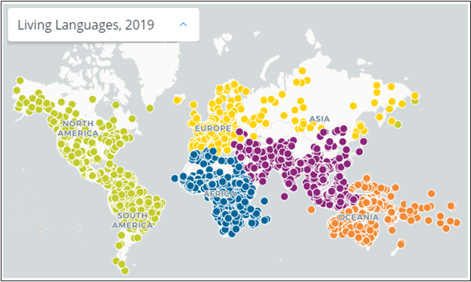

Fig 6.16: Map by Ethnologue by SIL International (Ethnologue, 2019)

Companies such as Microsoft recognize the gravity of losing the heritage of a language and have thus introduced languages such as *Yucatec Maya* and *Querétaro Otomi* in their list of supported languages in Microsoft Translator. This allows automatic translation to permanently bridge the translation gap between these endangered languages and the rest of the world. The systems were built using the Microsoft Translator Hub, a translation product which is available for free to allow any group to create its own unique translation systems. Even fictional languages such as Klingon from the TV Star Trek Series has been added to the Translator and has been available in Bing Translate since 2003.

Native to the Yucatan region of Mexico and Belize and descended from the language of the ancient Mayan empire, *Yucatec Maya* is spoken by fewer than 800,000 people, with less than 59,000 monolingual speakers. *Querétaro Otomi* is an endangered language from the State of Querétaro, in western central Mexico that is only spoken by 33,000 people and has fewer than 2,000 monolingual speakers.

Watch the video below to find out more about Microsoft Language Hub

[Video: Microsoft Translator Hub: Translation by Everyone for Everyone](https://youtu.be/-ylJ80quXcs)

# Using digital tools to preserve historical artifacts, paintings, and other works of art

According to the Internet Encyclopedia of Philosophy, “Interpretation in art refers to the attribution of meaning to a work”. In order to interpret a work of art there are two prevalent concepts of isolationism and contextualism.

The project aims to make art all over the world accessible and discoverable by all. In order to complete this task, it is therefore important to digitize, classify, and tag these works of art in a scalable manner. To demonstrate the scale of such a project, the Metropolitan Museum of Art alone has over 1.5 million works of art from more than 5,000 years ago. In collaboration with Microsoft, the museum launched its Open Access platform in 2017. The aim was to make the art collection more accessible to people not only physically, but also over the Internet. The joint effort uses AI to assist people in appreciating and developing a meaningful connection with these art pieces. Since it is a labor-intensive process, Microsoft and the Museum have jointly decided to make use of Microsoft’s Cognitive Search to examine each artwork. This generates the necessary information to create relevant tags and classify the artworks in a fraction of a second.

Watch the following video to find out more about a hackathon based on this project.

[Video: How Gen Studio was created for The Met using Microsoft AI](https://youtu.be/9etxRT1hq14)

AI For Accessibility

This program provides deserving organizations and people with a variety of disabilities access to the advanced Microsoft suite of services in order to support them in creating solutions to everyday activities and in many cases increase quality of life. The aim is to provide an Accessibility program that awards grants to projects which build on recent advancements in Microsoft Cognitive Services and Machine Learning to develop accessible and intelligent AI solutions in any of the following three areas of focus. These three areas are:

* **Employment** - How can AI positively impact the employment rate for people with disabilities by their use of more intelligent technology?
* **Daily Life** - How can AI increase access to technology for people with disabilities, while at the same time decreasing the cost of such technology?
* **Communication & Connection** – How can AI help improve the speed, accuracy, and convenience of communication for people with disabilities?

The free app Microsoft SEEING AI narrates the world around people with vision impairment. This is a part of a research projects designed to harness the power of AI to describe people, text and objects.

## Features of the App:

Watch this short video to see some of the features of the app that make it special:

[Video: Seeing AI app from Microsoft](https://youtu.be/bqeQByqf_f8)

To know more about Microsoft and its collaborations, visit the following links:

<https://www.microsoft.com/en-us/ai/ai-for-accessibility-projects?activetab=pivot1:primaryr3>.

<https://www.microsoft.com/en-us/ai/ai-for-accessibility-projects?activetab=pivot1:primaryr2>

AI for Humanitarian Action

AI for Humanitarian Action is a platform for Microsoft to partner with non-profit and humanitarian organizations working towards supporting global humanitarian problems such as child trafficking, disaster management, asylum, and legal aid for refugees and displaced people. This sub module deals with the contribution of Microsoft in the above-mentioned areas and its collaborations with various partners to deal with the humanitarian problems plaguing the world.

# Use AI-based recovery programs designed for disasters and emergencies

According to the World Bank, “Artificial intelligence could “end famine” by predicting developing crisis before they begin. The World Bank has launched the Famine Action Mechanism (FAM) in collaboration with international organizations such as the Red Cross, Microsoft etc., to use their expertise and services to prevent famines in the future. These organizations will use their expertise in AI and other technologies to direct the attention of the world to the problems and help tackle them. The forecast of an impending danger can help governments of the respective areas identify where the disaster is likely to strike, to take urgent measures in building capacities to counter it. Led by the UN, the World Bank, the International Committee of the Red Cross, Microsoft, and Amazon, the coalition will use the predictive power of AI and associated data to identify areas for early intervention and preparedness, thus improving the allocation and effectiveness of available funding. This coalition will be responsible for issuing early warnings in order that such threats can be identified and prompt counteraction taken on time.

**Monitor, detect, and prevent human rights violations**

Microsoft has collaborated with the Clooney Foundation for Justice to create innovative technology that can empower human rights trial monitors to capture multiple types of data in one place—and extract the information needed for experts to assess the fairness of a trial.

TrialWatch is an initiative of the Clooney Foundation for Justice focused on monitoring and responding to trials around the world that pose a high risk of human rights violations. To get a better idea of what TrialWatch is about, this video provides an introduction:

[Video: TrialWatch](https://youtu.be/AIMxei89iqU?t=145)

**Ensure the safety and well-being of children around the world**

Microsoft considers the safety and well-being of children of enormous importance. It recognizes that children are vulnerable to crimes such as human trafficking and uses both predictive analytics and bot frameworks to help NGOs and other organizations working towards the rehabilitation of children.

# Using speech-to-text AI and an Azure database to advocate for people seeking asylum

The Asylum Seeker Advocacy Project (ASAP) uses speech-to-text AI and an Azure database along with working with volunteers to provide legal aid to families who are fleeing their country fearing persecution. In this regard, AI services helps ASAP track court dates and assign priority to cases. It uses technology to reach out to people in remote locations of the world who otherwise may not be able to avail themselves of attorneys or legal aid.

Microsoft has pledged its support to ASAP to support refugees and displaced people. Through this 5-year program, Microsoft will use artificial intelligence and machine learning to improve the lives of over 70 million displaced people across the world, from which almost 26 million are refugees. Refugees and people displaced from their homes live a disrupted life. They deal with scarce resources and yet live their life with enthusiasm. Unwilling to give up, they strive to bring normality into their lives. Microsoft in partnership with the UN has come up with projects such as the “Asylum Seeker Advocacy Project (ASAP) and KIND, to help combat wrongful deportation of asylum seekers in the United States. Both organizations provide legal assistance to asylum seekers.

**AI for Health**

The health of people and communities around the world has been improving over time. For example, the steep decline in child and maternal mortality is a key indicator of positive momentum.

However, progress has not been equal across the globe, and there is a great need to focus on societal issues such as reducing health inequity and improving access to care for underserved populations. While researchers work to unlock life-saving discoveries and develop new approaches to pressing health issues, advancements in technology can help accelerate and scale new solutions.

That is why Microsoft are launching AI for Health, a new $40 million, five-year program to empower researchers and organizations with AI to improve the health of people and communities around the world. The program is underpinned with a strong foundation of privacy, security and ethics, and was developed in collaboration with leading health experts who are driving important medical initiatives. AI for Health is the fifth Microsoft AI for Good program, a $165 million initiative to empower researchers, nonprofits and organizations with advanced technologies to help unlock solutions to the biggest challenges facing society today.

The AI for Health initiative will focus on three key areas:

* **Quest for discovery.** Accelerating medical research to advance prevention, diagnoses and treatment of diseases.
* **Global health insights.** Increasing our shared understanding of mortality and longevity to protect against global health crises.
* **Health equity.** Reducing health inequity and improving access to care for underserved populations.

**Using AI to eliminate leprosy**

# Every year, there are over 200,000 new cases of leprosy but increasing early diagnosis can help limit transmission of the disease. Together, Microsoft and the Novartis Foundation are developing an AI-enabled digital health tool, which can accelerate early detection, helping the world toward leprosy elimination.

**Harnessing powerful tools for health equity**

PATH advances health equity by aligning innovation with the needs of underserved communities around the world.

Using AI and data science, PATH works to improve the diagnosis of diseases like tuberculosis and cervical cancer, detect and respond to disease outbreaks, and support efficient and effective health systems.

[Learn more about PATH](https://www.path.org/)

**Advancing the pace of scientific discovery**

The COVID-19 High Performance Computing Consortium, led by the White House, gives researchers access to world’s most powerful supercomputing resources that can help identify new ways to fight the virus.

**Addressing Sudden Infant Death Syndrome**

Machine learning and data analytics are helping scientists at Seattle Children’s Research Institute uncover the root causes of breathing disorders like SIDS (Sudden Infant Death Syndrome).

**Preventing blindness from diabetic retinopathy**

Diabetic retinopathy is a leading cause of blindness among working-aged adults across the world.

Early detection can reduce the risk of blindness by up to 95%. Intelligent Retinal Imaging Systems (IRIS) can use AI to identify vision threatening forms of disease through the evaluation of images.

Assessment

Sentiment analysis is widely applied to:

1. Reviews from customer
2. Survey responses
3. Online and social media
4. All of the above

Cortana is:

1. Microsoft’s Digital assistant
2. Intel’s Digital assistant
3. Facebook’s Digital assistant
4. Apple’s Digital assistant

True or False

* Artificial Intelligence uses instances created by human intelligence. (**True**/False)
* Language analysis cannot predict emotions. (**True**/False)
* Cortana is a personal assistant. (True/**False**)
* Video indexer can analyze videos and segment them. **(True**/False)
* Cortana can find programs in the computer and perform online searches. (**True**/False)

Practical Challenges

# Challenge 1

**Minecraft MakeCode:** Explore basic coding concepts and learn about Artificial Intelligence (AI) and Supervised Learning in this free Hour of Code lesson in Minecraft: Education Edition! Help the Agent prevent forest fires with Minecraft and MakeCode.

<https://education.minecraft.net/hour-of-code>

# Challenge 2

**Chatbots:** Try out some of the chatbots listed above. Spend some time interacting with the chatbots and note down any unusual or unexpected answers.

Things to consider:

* What was the purpose of the chatbot?
* How did it feel interacting with the chatbot? Did it feel like you were talking to a robot or a human? Why do you think this?
* Did you feel that the chatbot had a certain personality? Why?

Taking it further

# Activities to try

* Microsoft computer vision demo: <https://aidemos.microsoft.com/computer-vision>
* Microsoft Seeing AI app: <https://www.microsoft.com/en-us/ai/seeing-ai>
* Natural Language Processing demo: <https://aidemos.microsoft.com/luis/demo>
* Text analytics demo: <https://aidemos.microsoft.com/text-analytics>
* Microsoft AI route planner: <https://aidemos.microsoft.com/route-planner>
* Change black and white photos to color: [https://colourise.sg/#colorize](https://colourise.sg/)

Further Learning on Microsoft Learn

Microsoft Learn provides self-paced, digital learning resources to build skills and foundational understanding on technology. With step-by-step tutorials, hands on labs and learning modules, students can advance their knowledge and prepare for industry recognized certifications.

Check out this list of free courses to get started today to further your learning from this module, or visit [aka.ms/learnforstudents](https://docs.microsoft.com/en-us/learn/roles/student) for hundreds more courses – you can even get certified on [Azure AI Fundamentals](https://nam06.safelinks.protection.outlook.com/?url=https%3A%2F%2Fdocs.microsoft.com%2Fen-us%2Flearn%2Fcertifications%2Fexams%2Fai-900&data=02%7C01%7CTina.Jones%40microsoft.com%7Cb75b2586e5b242688a2808d849dea2b2%7C72f988bf86f141af91ab2d7cd011db47%7C1%7C0%7C637340567918470567&sdata=cfObP1UMNUDWUVWXpsb39ynNw%2FueOhHmpxe5xdRT9sc%3D&reserved=0)!

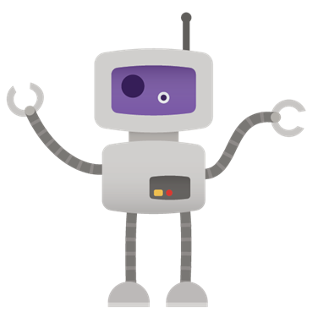

[Track Global Air Quality with Azure Maps](https://nam06.safelinks.protection.outlook.com/?url=https%3A%2F%2Fdocs.microsoft.com%2Fen-us%2Flearn%2Fmodules%2Fazure-maps-track-air-pollution%2F&data=02%7C01%7CTina.Jones%40microsoft.com%7Cb75b2586e5b242688a2808d849dea2b2%7C72f988bf86f141af91ab2d7cd011db47%7C1%7C0%7C637340567918340632&sdata=1u4FB40t1PfTJnEOxI3RQllbt0Gt8eu4W5IwWiBG6sQ%3D&reserved=0)

[Classify Endangered Bird Species with Azure Custom Vision](https://nam06.safelinks.protection.outlook.com/?url=https%3A%2F%2Fdocs.microsoft.com%2Fen-us%2Flearn%2Fmodules%2Fcv-classify-bird-species%2F&data=02%7C01%7CTina.Jones%40microsoft.com%7Cb75b2586e5b242688a2808d849dea2b2%7C72f988bf86f141af91ab2d7cd011db47%7C1%7C0%7C637340567918350628&sdata=S6AdX9WqLDidEiCJ2DQZqp95HydX%2FaQaA5pNKe9zrDc%3D&reserved=0)

[Create a Chat Bot to Help Students Learn with Azure Bot Service](https://nam06.safelinks.protection.outlook.com/?url=https%3A%2F%2Fdocs.microsoft.com%2Fen-us%2Flearn%2Fmodules%2Fresponsible-bots%2F&data=02%7C01%7CTina.Jones%40microsoft.com%7Cb75b2586e5b242688a2808d849dea2b2%7C72f988bf86f141af91ab2d7cd011db47%7C1%7C0%7C637340567918360621&sdata=Hz9OWA8M3THQToLhZx8SkPqKE4GURTDNRD79KLlTvDQ%3D&reserved=0)

[Help Remote Farmers Protect their Crops with Weather Alerts using Azure Functions](https://nam06.safelinks.protection.outlook.com/?url=https%3A%2F%2Fdocs.microsoft.com%2Fen-us%2Flearn%2Fmodules%2Fsend-crop-weather-alerts%2F&data=02%7C01%7CTina.Jones%40microsoft.com%7Cb75b2586e5b242688a2808d849dea2b2%7C72f988bf86f141af91ab2d7cd011db47%7C1%7C0%7C637340567918360621&sdata=R%2BqXgV%2Bnu1sagB%2Fk%2BjElqy4qi5UZQ9cVrLyhdFJCK5c%3D&reserved=0)

[Track Wild Polar Bears with Stream Analytics and Machine Learning Classification](https://nam06.safelinks.protection.outlook.com/?url=https%3A%2F%2Fdocs.microsoft.com%2Fen-us%2Flearn%2Fmodules%2Fbuild-ml-model-with-azure-stream-analytics%2F&data=02%7C01%7CTina.Jones%40microsoft.com%7Cb75b2586e5b242688a2808d849dea2b2%7C72f988bf86f141af91ab2d7cd011db47%7C1%7C0%7C637340567918370618&sdata=s77bAuARqSnc72T3mixy9atXFKbRsJbf2apfG3IqnhU%3D&reserved=0)

[Analyze Climate Data with Azure Notebooks](https://nam06.safelinks.protection.outlook.com/?url=https%3A%2F%2Fdocs.microsoft.com%2Fen-us%2Flearn%2Fmodules%2Fanalyze-climate-data-with-azure-notebooks%2F&data=02%7C01%7CTina.Jones%40microsoft.com%7Cb75b2586e5b242688a2808d849dea2b2%7C72f988bf86f141af91ab2d7cd011db47%7C1%7C0%7C637340567918380618&sdata=pLGZPT%2BeBhpn12d0mECH47lXC1Ie0gc57S%2BVzkeLoPo%3D&reserved=0)

Explore Computer Vision

**Reference Links**

* Azure.microsoft.com. (2019). Bing Spell Check| Microsoft Azure. [online] Available at: https://azure.microsoft.com/en-in/services/cognitive-services/spell-check/ [Accessed 29 Jun. 2019].
* Azure.microsoft.com. (2019). *Face API - Facial Recognition Software | Microsoft Azure*. [online] Available at: https://azure.microsoft.com/en-in/services/cognitive-services/face/ [Accessed 29 Jun. 2019].
* Bayern, M. (2019). 6 ways AI will revolutionize retail. [Online] TechRepublic. Available at: https://www.techrepublic.com/article/6-ways-ai-will-revolutionize-retail/ [Accessed 3 Jul. 2019].
* Docs.microsoft.com. (2019). Generate data insights automatically with Power BI - Power BI. [online] Available at: https://docs.microsoft.com/en-us/power-bi/service-insights [Accessed 11 Jul. 2019].
* Eisenhauer, T. (2014). How Online Collaboration Tools Benefit Your Business. [online] Axero Solutions. Available at: https://axerosolutions.com/blogs/timeisenhauer/pulse/180/how-online-collaboration-tools-benefit-your-business [Accessed 11 Jul. 2019].
* Greene, J. (2019). 21 Ways AI Is Transforming the Workplace in 2019 • Spoke. [Online] Spoke. Available at: https://www.askspoke.com/blog/support/how-ai-is-transforming-workplace/ [Accessed 3 Jul. 2019].
* Hudson, M. (2019). Artificial Intelligence in Retail. [Online] The Balance Small Business. Available at: https://www.thebalancesmb.com/how-artificial-intelligence-will-change-retail-4143281 [Accessed 3 Jul. 2019].
* Ibm.com. (2019). *Cloud computing: A complete guide*. [online] Available at: https://www.ibm.com/cloud/learn/cloud-computing [Accessed 29 Jun. 2019].
* Intel. (2019). The Future of AI in Agriculture - Intel. [Online] Available at: https://www.intel.in/content/www/in/en/big-data/article/agriculture-harvests-big-data.html [Accessed 3 Jul. 2019].
* Kashyap, V. (2019). 28 Best Online Collaboration Tools of 2019 for Business. [online] ProofHub. Available at: https://www.proofhub.com/articles/best-online-collaboration-tools-business [Accessed 11 Jul. 2019].
* Microsoft New Center, India (2017). Digital Agriculture: Farmers in India are using AI to increase crop yields. [Online] Available at: https://news.microsoft.com/en-in/features/ai-agriculture-icrisat-upl-india/. [Accessed 21 November 2019].
* Prezi.com. (2019). Collaboration Tools. [online] Available at: https://prezi.com/p/gpqlovdvt3ia/collaboration-tools/ [Accessed 11 Jul. 2019].
* PwC. (2019). No longer science fiction, AI and robotics are transforming healthcare. [Online] Available at: https://www.pwc.com/gx/en/industries/healthcare/publications/ai-robotics-new-health/transforming-healthcare.html [Accessed 3 Jul. 2019].
* Symanovich, S. (2019). How does facial recognition work? [online] Us.norton.com. Available at: https://us.norton.com/internetsecurity-iot-how-facial-recognition-software-works.html [Accessed 9 Sep. 2019].
* Trivedi, S. (2019). How AI will Change the Retail Industry in 2019? - Data Driven Investor - Medium. [Online] Medium. Available at: https://medium.com/datadriveninvestor/how-ai-will-change-the-retail-industry-in-2019-c817091c6306 [Accessed 3 Jul. 2019].Types of Cloud Computing: Private, Public, and Hybrid Clouds | Technology Services - University of Illinois at Urbana-Champaign. 2019. Types of Cloud Computing: Private, Public, and Hybrid Clouds | Technology Services - University of Illinois at Urbana-Champaign. [Online] Available at: https://cloud.illinois.edu/types-of-cloud-computing-private-public-and-hybrid-clouds/. [Accessed 03 July 2019].
* UN DESA, P. (2015). World population projected to reach 9.7 billion by 2050 | UN DESA | United Nations Department of Economic and Social Affairs. [Online] Un.org. Available at: https://www.un.org/en/development/desa/news/population/2015-report.html [Accessed 3 Jul. 2019].

Glossary

**Algorithm**: A process or set of rules to be followed in calculations or other problem-solving operations, especially by a computer.

**Chatbots**: A computer program designed to simulate conversation with human users, especially over the Internet.

**Cloud Computing**: Cloud Computing is a system using a robust network of remote computers (called servers) hosted on the Internet that store, manage, and analyse data

**Cloud Storage**: It is a service model in which data is maintained, managed, backed up remotely and made available to users over a network (typically the Internet). Users generally pay for their cloud data storage on a per-consumption, monthly rate.

**Computer Vision:** Computer vision is a field of artificial intelligence (AI) that trains computers to interpret and understand the visual world.

**Intelligence** – capability to obtain knowledge and skills and apply it to various situations without supervision.

**Machine Learning**: Machine learning is an application of artificial intelligence (AI) that gives machines the ability to automatically learn and improve from experience without being explicitly programmed. Machine learning focuses on the development of computer programs that can access data and use it learn for themselves.

**Natural Language Processing:** Natural Language Processing (NLP) is a field of artificial intelligence (AI) that helps computers understand, interpret and manipulate human language.

**Supervised Learning**: Supervised learning is an approach to creating artificial intelligence (AI), where the program is given labeled input data and the expected output results.

**Unsupervised Learning**: Unsupervised learning is an approach to creating artificial intelligence (AI), where the program looks for previously undetected patterns in a data set with no pre-existing labels and with minimum human supervision.

**Virtual** – Not physically existing as such but made by software to appear to do so.

